GIT BRANCHING

SECTION-2 - (CSS assignments) Steps to follow:

1. Create a new branch ‘css-assignments’.



2. Switch to ‘css-assignments’ branch.



3. Copy all CSS assignments inside ‘Assignments’ folder.



4. Commit CSS assignments into ‘css-assignments’ branch.

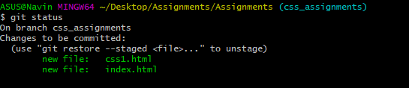

5. Make minor changes into README.txt file on line 1 belonging to ‘css-assignments’ branch

.

6. Commit those changed files.

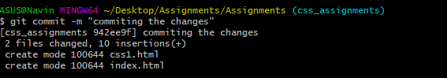

7. Switch to master branch.



8. Make minor changes into README.txt file on line 3 & commit those changes into master.

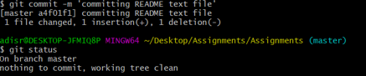

9. Again switch to ‘css-assignments’ branch.

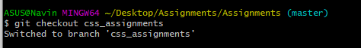

10. Make minor changes into few files belonging to ‘css-assignments’ branch.

11. Commit those changes.

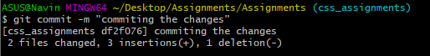

12. Switch to master.



13. Merge ‘css-assignments’ branch into master. Confirm all css assignments are shown in master.

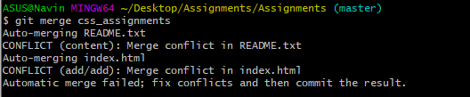

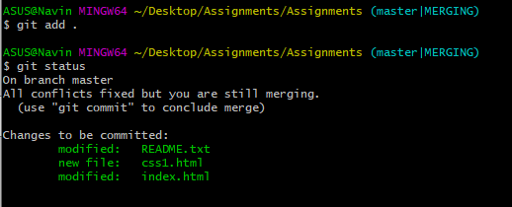

14. Finally delete the ‘css-assignments’ branch.

